4th Grade Supply List

General 4th Grade List
- 20 Cap erasers*  - 36 Pencils*  - 24 count crayons (no larger boxes)  - 2 large glue sticks  - Scissors (school appropriate)  - 1 package of WIDE ruled loose leaf paper  - 1 1.5” Clear View binder  - 3 containers of disinfecting wipes*  - 3 boxes of tissues*  - 1 pair of earbuds (must be wired) in a hard case | Folders  The color, pockets, and prongs are important.  - 1 blue folder (3 prongs/2 pockets)  - 1 yellow folder (3 prongs/2 pockets)  - 1 purple folder (3 prongs/2 pockets)  - 1 red folder (3 prongs/2 pockets)  Please do NOT label. The teachers will do this when school begins.
* These items may need to be restocked throughout the year.

Individual Teachers (additional items)
Rippe | McKee
- 2 dry erase markers  - 1 pencil pouch  - 1 Wide ruled spiral notebook  *Can have headphones or earbuds but need a case to put it in. | - 1 bottle hand sanitizer with pump (8-10 oz)*  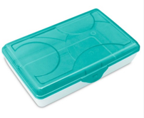  - Supply box - 9”x6” roughly
Garrett | Rigsby
- Colored pencils  - 1 box washable markers  - 1 7.6 oz bottle of liquid Elmer’s glue  - 3 highlighters (1 each pink, yellow, orange )  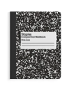  - 10 dry erase markers ( black only )  - 6 wide ruled composition notebooks  (no wired spiral notebooks)  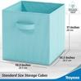  - 1 bottle hand sanitizer with pump  - Small collapsible cubby box 11 x 11 inches  - 1 box gallon sized Ziploc bags (boys only)  - 1 box quart sized Ziploc bags (girls only) | - Supply Box - 8”x5” box roughly  - 8 (or more) Piece Binder Dividers

